Amos Mobile 3.0.1 – Upgrade

1 Bug Fix 3.0.1 2

2 How To Upgrade 2

3 Initialize Database 4

Kevin Saegerman

07/08/2015

# Bug Fix 3.0.1

In Amos Mobile version 3.0.0 there is a bug related to the length of the location ID’s.  
ID’s longer than 10 digits will not be accepted by the barcode scanner.

Release 3.0.1 will fix this problem.

# How To Upgrade

* Connect your mobile device with the PC.
  + On Windows XP, use Active Sync
  + On Windows 7, use Windows Mobile Device Center
  + With both tools you will be able to browse the content of the device

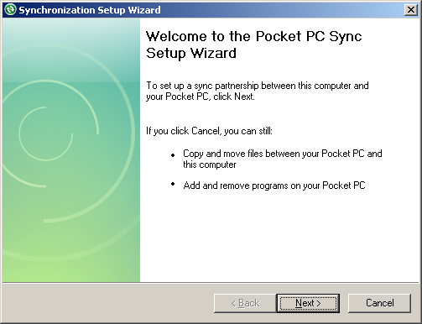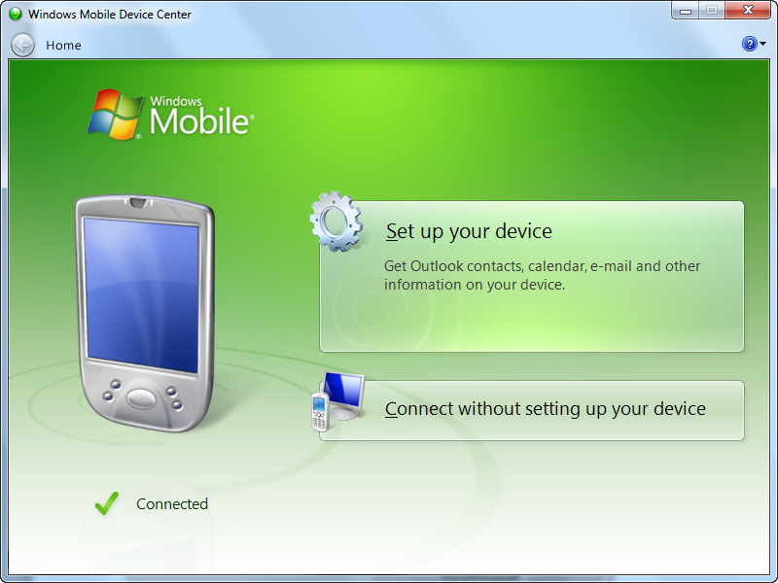

* Copy the installer file on the Storage Card of the mobile device
  + Browse to Storage Card\Install
  + Remove the existing Jdn.Amos.AmosMobile.CAB file
  + Copy **Jdn.Amos.AmosMobile3.0.1.CAB**
* Install version 3.0.1
  + Execute the following steps, depending on the version of Windows Mobile

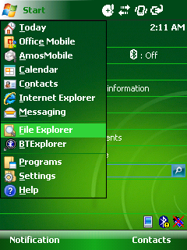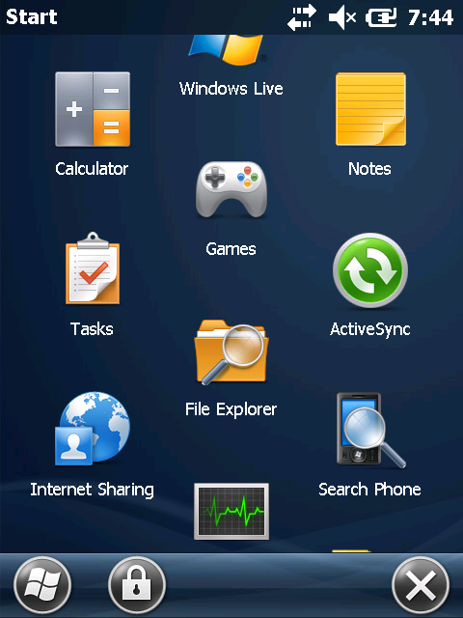

* Go to the main menu
* Click on “File Explorer”

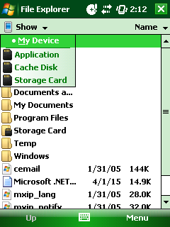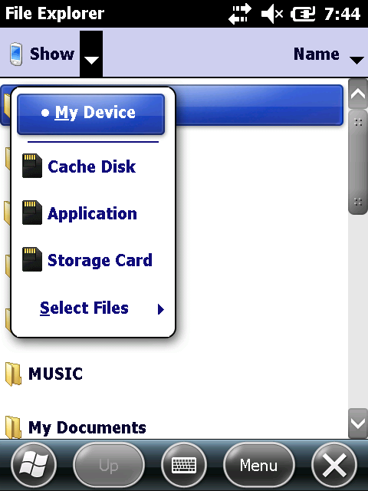

* In the top left corner you should see a dropdown with a downwards facing arrow next to it. Click on this.
* Click on ‘Storage Card’
* Click on the folder ‘Install’
* Install (or re-install) Amos Mobile (When asked for the location to install, choose “\Application”)  
  

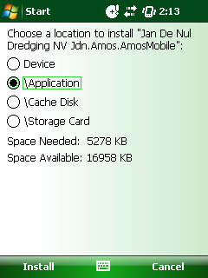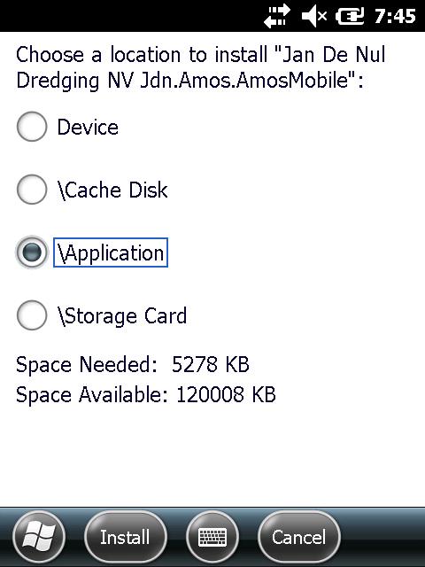

* It might ask to replace the previous version, click on ‘OK’
* Reboot the device (by holding the red power button for 6 seconds)

# Initialize Database

After the installation the mobile device has to be initialized again.

See Chapter 2 of the User Manual.